C-BAND MIMO DUAL POLARIZED - SPATIAL & POLARIZATION DIVERSITY-BROADBAND ANTENNA

Model HYC-MIMO-SAPDBA-469 4000 – 6400 MHz. 2x100 Watts 2X9 dBi. Gain

DESIGN FEATURES: The HYC-MIMO-SAPDBA-469 dual polarized antenna is designed to provide wideband Symmetrical sectors by 60° in H and E planes transmission/reception of horizontal and vertical polarized radio signals from 4000 to 6400 MHz bands. The ruggedized design improve mechanical durability of antenna in harsh environment. The specially designed mounting arrangement results in fast installation. This dual polarized MIMO space diversity antenna system is particularly suitable for transmission, reception, monitoring, applications for mobile applications on trains, rail and roads, cable rail, track side radio relay, due to its capability of receiving/transmitting both the E & H polarized signals simultaneously in spatial diversity. The flat gain and very high port isolation provides strong performance over the entire frequency of 4000-6400 MHz.
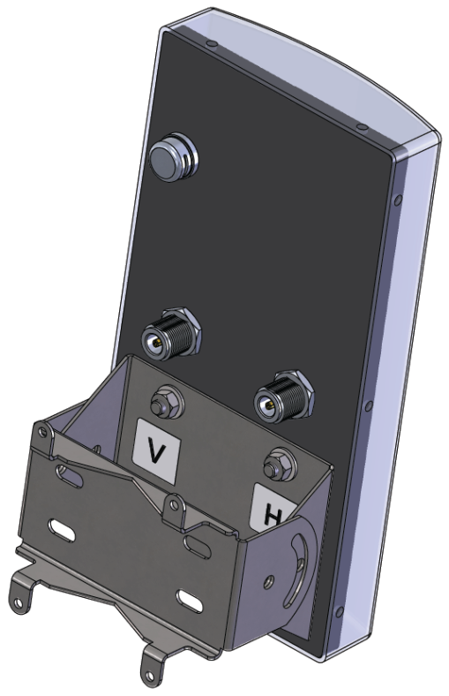
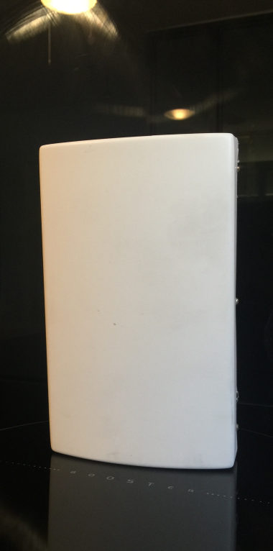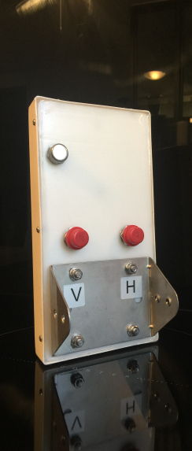
Goretex valve for pressure balancing and moisture removal

CONSTRUCTIONS: The HYC-MIMO-SAPDBA-469 antenna operates at D.C. ground with low resistance discharge path for protection against lightning and immunity to noise. All the screws, nuts and bolts of antenna are made of stainless steel.

MECHANICAL SPECIFICATIONS:
RECOMMANDATIONS :
Selon la puissance injectée ne pas stationner dans l’axe de l’antenne à moins de 10 mètres pour une puissance de 2x0.5 watts émetteur (8 watts de PAR). {Calculateur des distances de sécurité } Rester en deçà du seuil maximal des niveaux règlementaires.
Consulter le Portail Radiofréquences de l’Etat Français
Support Radiating Elements Materials | Delrin and gold-plated copper
Mounting Hardware -Materials | Marine Grade Stainless Steel
Net Weight Approx. | <1.2 Kg.
Wind Rating | 180 km/Hr.
Size H,L,W,Mount | 235 x125x40 +75 mm
Radome | ABS
Mounting Clamps Position | @ back of the Boom
Maximum Mount Pipe Diameter | 50mm
ENVIRONMENTAL SPECIFICATIONS:
Operating Temperature | -40 to + 85 Degrees Celsius
Storage Temperature | - 50 to +85 Degrees Celsius
Humidity  Pressure balancing and moisture removal | 0 to 95 % RH  Goretex valve

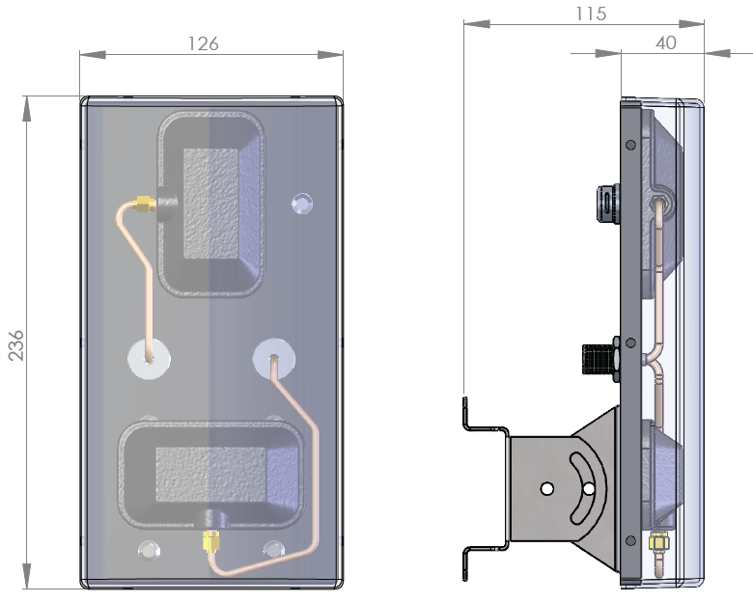
Goretex valve for pressure balancing and moisture removal

ELECTRICAL SPECIFICATIONS:
RECOMMANDATIONS :
Selon la puissance injectée ne pas stationner dans l’axe de l’antenne à moins de 40 mètres pour une puissance de 2x100 watts émetteur (1800 watts de PAR). {Calculateur des distances de sécurité } Rester en deçà du seuil maximal des niveaux règlementaires.
Consulter le Portail Radiofréquences de l’Etat Français
Frequency Range | 4000-6400 MHz.
Gain-Typical  Port isolation-Typical | 2x9 dBi  60 dB.
Bandwidth | Entire Band
Polarization | Dual – V & H
Input Impedance | 50 Ohms
Radiation Pattern | Directional
Horizontal Beam-width–Half power Points. | 60 Degrees Typical
Front to Back Ratio | 30 +/- 3 dB. Typical
VSWR – Better Than | 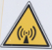  1.5:1
RF Power Handling Capacity | 2x100 Watts
Input Termination | 2 x N-Female
Lightning Protection | DC Ground
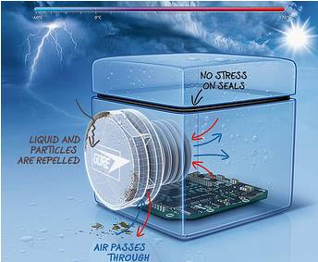
Enclosures and containers are vulnerable. Vulnerable to failed seals, condensation and contamination. Vulnerable to leakage and structural failure.
How likely is an enclosure or container to fail? All it takes is a change in internal pressure that stresses seals and antenna radome. Even a change in temperature or altitude could cause a pressure change, or it could happen because the contents of a container outgas or scavenge oxygen. In the case of mobile devices, enclosures could fail if they’re inadequately protected against liquids, dust and other environmental factors. Whatever the cause, the result could damage a product’s performance and integrity, or even lead to an expensive product failure or significant clean-up.
GORE Vents keep the worst from happening. They allow enclosures and containers to breathe, equalizing pressure and reducing condensation while filtering out liquids and other contaminants. The result: greater product performance, increased durability, higher reliability and peace of mind.

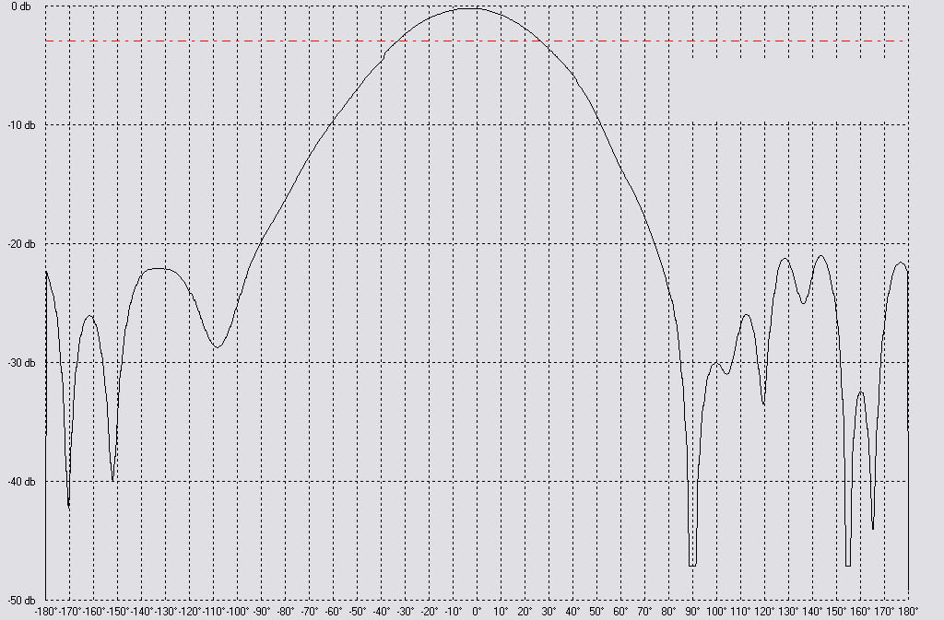

Beam-with 60° @-3 dB

Fréquency 5.5 GHz. E plane in Vertical polarization or H plane in horizontal polarization

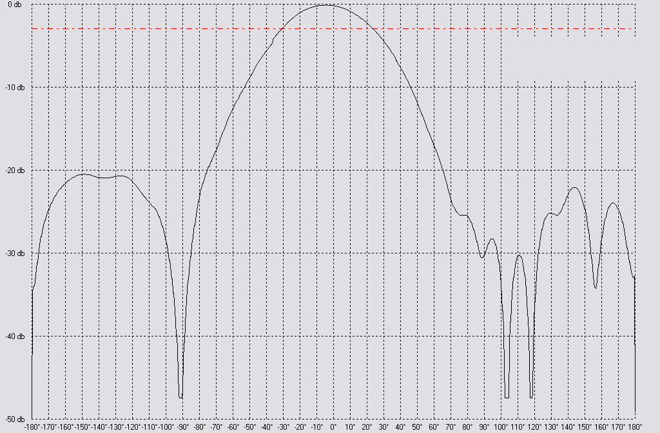

Beam-with 55° @ -3 dB

Fréquency 5.5 GHz. H plane in Vertical polarization or E plane in horizontal polarization
www.antennaexperts.fr

